Silent Weekend Report 2014

The Executive Summary
The Silent Weekend initiative was conceived in an attempt to draw attention to the experiences of a number of children at some youth games whilst acknowledging that the vast majority of matches are played in a safe and enjoyable environment in front of supportive and well-behaved adults. The whole purpose was to see how we can make those experiences consistently positive through attitudinal and logistical changes.
The weekend was held on the 8th and 9th March 2014 and over two hundred clubs incorporating two thousand teams participated throughout the county. The event attracted national and local media interest ranging from BBC Breakfast and Sky Sports, to our regional newspapers and local radio stations. This had the critical effect of bringing the Silent Weekend to a huge audience with social networks taking it to an international dimension.
As part of the Silent Weekend plan, we asked coaches, parents, players, and referees to share their opinions via an online survey. The number of respondents exceeded thirteen hundred and fifty and their answers along with qualitative commentary has been of enormous benefit in shaping the recommendations made. These recommendations summarised below, and explored in greater detail later, are intended for consultation and comment. It is sincerely hoped that from those deliberations come ideas and changes that can best protect the interests of children and young people in future, better inform the adults present, and hence ensure the long-term viability of football at youth level in our fine county.

The Recommendations Summary
1. Coaches to stand in coaching areas during all grassroots youth football games. Referees to monitor adherence and report any breaches to the league.
2. Coaches to refrain from shouting negatively at players and should only communicate when absolutely necessary.
3. Coaches of Under Eleven teams and younger should rotate their squads to allow roughly equal game time during a season. This to be an expectation of all clubs, leagues, and the county FA.
4. Parents to refrain from offering any coaching advice or instruction to their children. Vocal output to be limited positive encouragement of all players irrespective of team. Clubs to be responsible for policing adherence.
5. Lancashire FA to recruit a Youth Council to be in place from September 2014 with membership open to applicants from all stakeholder groups between the ages of fourteen and twenty-five.
6. Clubs to create a youth committee or elect a youth member onto the full club committee for the 2014-15 season. Leagues to have youth committee member by 2015-16 season.
7. Leagues to liaise with local Referees Associations to plan and deliver a Mentoring Programme for young and inexperienced referees. Both leagues and RAs to consider using existing funds to cover travelling expenses of mentors or to reward their commitment in other ways.
8. Local Referees Associations to offer free membership for the first year to all newly qualified referees and ensure each is contacted directly to extol the intrinsic value of membership.
9. Lancashire RA to have a youth council reporting to the main committee ensuring that all young officials have a forum whereby their opinions and concerns can be articulated without fear or favour.
10. Leagues to offer a Hospitality Award to the team given highest grades by visiting teams on post-match feedback forms. This could be on a league or divisional basis.
11. All clubs to consider hosting Adults In Junior Football Workshop during 2014-5, or a different follow-up session for those clubs who have previously accessed it.
12. Leagues with insufficient qualified referees to work closely with local RA and Lancashire FA Referees Department to look at recruitment and retention initiatives.
13. Leagues to host a course for club assistants organised in conjunction with the local RA and county FA Referees Department to cover basic duties of the job and offer consistent advice on the interpretation of offside. No coaching to be given from the line. Each team to be encouraged to recruit a designated person to fulfil these duties as regularly as possible.
14. Leagues to split all games into four periods to allow coaches time outside of the game to help their young players and make any necessary amendments. This to be achieved through liaison with referees, the extra breaks to be classed as refreshment breaks and limited to two to three minutes.
15. Leagues to make Adults In Junior Football Workshop mandatory where the league feels a team or club’s behaviour is unacceptable.
16. Lancashire FA to create a Youth League Forum from its existing WO Working Group. Forum to be representative of clubs, leagues, and other stakeholders, be independently chaired, and to have scope to make recommendation to county FA.

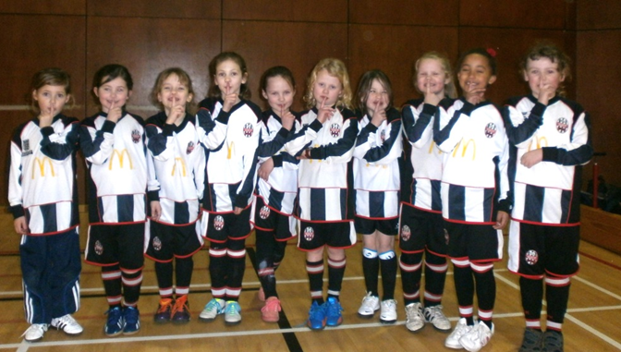

The Acknowledgement
Lancashire FA would like to place on record its sincere appreciation of all of those people and organisations whose support and hard work brought a loosely planned initiative to fruition. We would like to thank the Board of Directors and Council of the Association for sanctioning the Silent Weekend. We are indebted to our youth leagues which embraced the idea and were persuasive in encouraging their member clubs to participate. We would like to thank those clubs who signed up for the event and those who participated on match day resulting in the involvement of in excess of two thousand teams. Within those clubs we would like to thank the officers, coaches, players, and parents/carers who observed the event so well despite several of them having fundamental misgivings as to its necessity. We would like to thank the various media outlets both national and local who took time out to interview staff and volunteers and produce reports which were highly supportive of the idea. We are also grateful to our neighbouring county FAs who encouraged their own clubs and leagues to uphold the principles of the Silent Weekend where Lancashire teams were involved.
Much of the early impetus and encouragement for the basic idea of the Silent Weekend came from social networks where national and even international feedback was overwhelmingly positive. Special mention must go to Elmswell Youth FC of Suffolk who had previously trialled this initiative locally and offered artwork and advice with good grace. The steering committee set up to oversee this weekend offered very useful advice and we are grateful to Warren Barlow, Lesley Allon, Peter Thornton, and Nigel Dixon. Last but not least we must applaud our own staff who supported the idea, administered the website, and attended games at various venues over the weekend.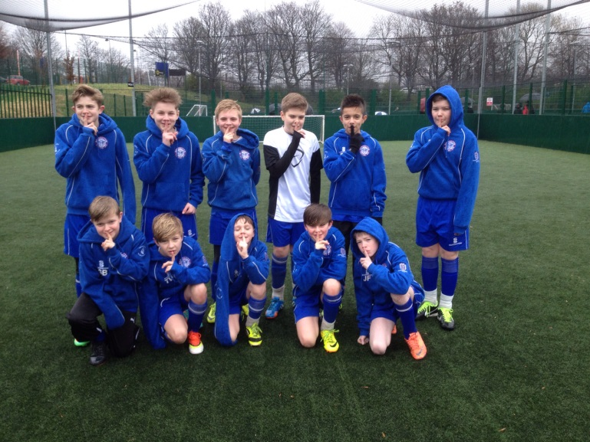
The Rationale
The concept of the “Silent Weekend” evolved from first-hand witnessing of a game earlier in the season where a nine year-old child was visibly intimidated and upset by a small group of adults standing on the touchline. This was not abusive or offensive language but a level of noise more akin to that heard in the stands at a professional football match. Those responsible clearly did not intend to cause upset to such a young player but it was immediately evident that the prevailing environment was not conducive to player enjoyment or development. The child’s father suggested afterwards that his child should not be forced to endure adult behaviour that adversely impacted on his football experience.
This witness account began a thought process as to how we might draw attention to the need for adults to behave differently at children’s football than when watching an adult game. It is clear from the fact that we still receive poor practice reports that some adults fail to act responsibly on the touchline and become too absorbed in a junior game which they have mistaken for their own. The challenge was to draw attention to the fact that other than kicking a spherical object between two posts, there is nothing in common between games at youth and senior levels. Children are motivated differently to adults. The ability of children to learn and develop is inevitably affected by adult input and influence. The opportunity to play with independence, with creativity, and with problem-solving capacity is regularly compromised by adults shouting often conflicting instructions which can further confuse players and make them reluctant to receive the ball or experiment with it.
The challenge was to draw the attention of the youth football fraternity in Lancashire to some of these important issues, some of which they may not previously have considered, and attempt to provoke a debate as to how we could make the match-day environment consistently safe, enjoyable and bereft of undue pressure. Whilst an ongoing educational programme exists and remains the focal point of the work of the County Welfare Office, it was felt a distinct event that drew attention to these issues for one weekend might be an effective innovation.

The Evolving Plan
In depth discussions were held within the county FA to determine how the initiative might proceed. It was felt appropriate to canvas the views of those immersed in the grassroots game and hence a steering group was created comprising the Lancashire FA Chief Executive, County Welfare Officer, Senior Football Development Officer, League Chairman, League Welfare Officer, League Secretary, and the Chairman of a Charter Standard Community club. There was understandably some debate about what name was given to the weekend and the extent of the behavioural changes required. Some believed positive reinforcement should be encouraged and perhaps the name Positive Weekend be adopted. However it was considered that this might not carry the same impact and hence the same potential to be exploited within various media circles. It was also felt that we needed to draw a significant distinction between “normal” behaviour and the weekend with noise levels substantially reduced.
It was agreed to create a leaflet which could be hosted on the county FA website and downloaded by clubs along with a Frequently Asked Questions page. It was also deemed essential to create a separate survey for each of the stakeholder groups to reflect and report back on their experiences so as to richly inform consideration of any future changes. Some leagues stated a willingness to invest in visible resources to act as a tangible reminder that the Silent Weekend was different. The county FA pledged to make a contribution to any league spending in excess of one hundred pounds. The initiative was actively promoted via the county FA website, the county FA e-zine, and social media. Indeed a leading national football writer “retweeted” an early county FA feed. It was agreed to hold a prize draw for all participating. One member of the group with long experience of publishing and media offered to explore the potential for professional art and design work at an affordable price.
We created a designated e-mail address via which clubs could offer official support before their names, and those of supporting leagues, were transferred to an evolving list on the county FA website. We also used the website to offer updates as plans were tweaked during the evolution of the project. This page was the focal point of our communication with our clubs although e-zines were regularly compiled and the county FA Twitter feed regularly signposted individuals and clubs to this source of information.
Over the ten week period between the initial plans, and the Silent Weekend taking place, over two hundred clubs signed up via the e-mail address. All of our youth leagues embraced the project and several made strenuous efforts to gain the maximum buy-in from their member clubs. This local management of the project was vital if we were to see widespread observance and those in leagues and clubs who championed the idea, and persuaded waverers to uphold its core values are to be applauded as without these local efforts, the success would have been significantly diluted.
The leaflets which had been professionally designed explained the rationale behind the Silent Weekend and by asking clubs and leagues to print sufficient copies meant the county FA was seen to be discharging its social responsibilities in terms of reducing waste paper. The surveys were created for each participant group and contained brief, age-appropriate questions. It was hoped that we might receive around one hundred completed forms to give us both quantitative and qualitative feedback on the experiences of those taking part. When the surveys were closed ten days after the weekend we were overwhelmed to see we had attracted over thirteen hundred and fifty responses. The feedback and comments from those surveys are summarised later in this report.
Much of the media interest in the project came at the eleventh hour with extensive national, regional, and local coverage which proved logistically challenging in meeting the demands for interviews and filming during the weekend. Again we sincerely appreciate those clubs and leagues which assisted in accommodating cameras, and offering quotations to the press, radio, and visual media. In attracting national recognition we have inevitably received expressions of interest from other county FAs, leagues, and clubs and we have sought to offer as much advice and guidance as possible to those seeking possible replication.
The final part of the plan was to create this consultation document based on the survey findings and comments but critically making some recommendations for future innovations that might improve further the touchline environment on a consistent basis. The document is to be discussed initially by the steering group and the county FA council before being released to our clubs, leagues, the national governing body, and further afield. The whole crux of this project has been to stimulate a debate into how we can better educate and inform, and how we can make practical suggestions that have long term effect. This is intended to build on the excellent work done by the FA through its Youth Review and the structural changes to the youth game which it is overseeing can only be complemented by any attitudinal changes we can help to nurture.

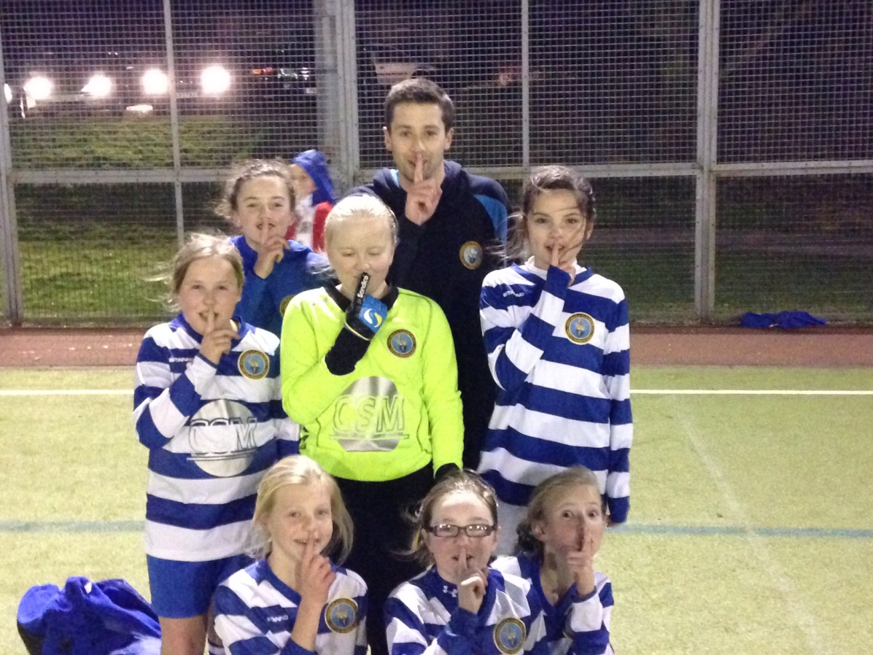
The Theory
For some considerable time Lancashire FA has sought to embrace educational solutions to the issues of poor practice in youth football. Previously we had used disciplinary sanctions such as fines and suspensions as our main weapon in dealing with offenders but it was clear that in most cases this was a sticking-plaster solution to a much more deep rooted issue of a failure of adults to differentiate between adult and youth football, between what motivates children and adults, and how children best learn, develop, and enjoy the game. As a consequence we developed our Adults In Junior Football workshop which we have delivered in the past three years to upwards of sixty clubs and leagues. This appears in terms of re-offending to have a demonstrably positive effect. Given its success we have looked to offer a follow-up workshop looking at match day scenarios and issues, and other areas of concern within clubs where education will hopefully prevent members from getting into subsequent difficulties.
The drawback with organising workshops is that we can only access the audience present, and often that represents a case of “preaching to the converted” with those to whom the education would be best targeted often absenting themselves from the session. Similarly, as the workshop is offered on a voluntary rather than mandatory basis, we find that the more proactive clubs are keen to host us whereas those to whom it might be more appropriately delivered failed to take up the opportunity.
In effect this means the number of individuals with whom we have the chance to engage represents a small minority of those who regularly attend youth football matches in the county. In the conception of the Silent Weekend we realised we needed to maximise the numbers of people who were required to abide by its principles by their clubs and leagues. By involving literally thousands of adults we were hoping that each individual standing on the touchline during Silent Weekend might reflect on why it had been deemed necessary, and how they might consider their own behaviours in future. Of course the reality was that a sizeable number would dismiss it as a gimmick or cosmetic exercise but even if a percentage used the project as a platform to rethink their coaching methods, or what they shouted during a game, then only positives could be derived.

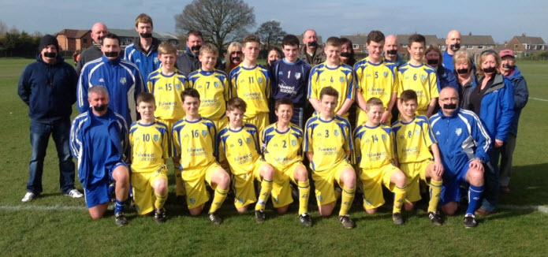
Parents/Carers
The first group we wished to address was our parents and carers. This is a vital stakeholder group in youth football because simply without their support and logistical input, children would not be able to play football in a structured environment such as clubs and leagues. The vast majority of parents and carers behave impeccably during youth football matches offering positive encouragement and applause to their own child and his/her team-mates. It is very important to place on record the sincere appreciation of Lancashire FA to our thousands of parents and carers who give their valuable time to ensure children can enjoy football around our county. There were two specific issues we were seeking to address with this group. The first was to embrace the concept of applauding both teams during the game rather than the traditional parochial outlook inherited from the adult and professional games. Every single individual standing on the touchline has the opportunity to praise every child who performs well, or carries out an individual act of excellence. Sadly however, on too many occasions adults feel constrained from so doing by the shirt colour of the child concerned. Children are fairly clear on this. They appear to want parents and carers to cheer, applaud, and praise both teams. Omli (2008) quotes an eight year-old girl who, when questioned on this issue said “Parents should cheer for both sides so they all feel like they are having fun. It’s just for fun. It’s not anything about winning.”
Society has a duty to nurture and develop its most precious resource, its children. Grassroots football is not exempt from that reality. Yet too many of us feel unable to positively reinforce excellent play because we are encumbered by strict adherence to the club for which our team plays. The assumption is that any praise afforded to any opposing player might give his team a lift and thus deny your child’s team a victory. In so doing the result of a match has become more important than developing the football and life skills of all of its participants. This paradox has been addressed by the FA in its youth review which has resulted in the non-collation of results and the non-compilation of league tables in ever increasing age groups to bring us into line with much of mainland Europe Once the restrictive handcuffs of results are removed, the fragile excuse for not praising both teams is surely shattered? It is undeniable that children benefit from positive comments and praise and this has a direct impact on their levels of confidence, not just on the football field, but in the world beyond the game. Taylor (2005) says that praising children in the right way emphasises the intrinsic reward for acting as they did. However, he also points out that it is essential to praise qualities such as hard work, effort, diligence and patience rather than merely the outcome of those qualities. In other words if a child loses, it is still possible to praise them for the contribution they have made within the game. That contribution of course outweighs the result.
The second issue we felt parents and carers might wish to consider was shouting negatively at their own offspring during the game, or offering coaching advice from the touchline which might conflict with that being offered by the designated manager or coach. How children learn is addressed below but any visit to a school classroom is unlikely to result in the visitor witnessing teachers routinely bellowing at children, or indeed teaching assistants telling children to sit down at the same time the teacher is requesting they stand. The detrimental effects of shouting at children in a sporting setting have been well documented. Goldberg (2004) concludes that yelling at children often distracts them from the game, turns them off the sport, and ultimately shuts them down in terms of performance. The pervasive and pernicious effect of these unwanted parental interventions are often not considered by parents and carers, some of whom will genuinely think they are offering constructive developmental advice and guidance. However, according to Kidman et al (1999) the significant amount of instruction from parents on the touchline, and the level of negative comments recorded give rise for concern. He believes there is a need for interventions to educate and inform parents on how to provide a more supportive and positive sporting experience for all children present. The purpose of the weekend was not to prevent parents from positive encouragement which is clearly welcome, but to ask them to reflect whether they might ever shout negatively or indeed contradict coaches with alternative instructions to their children delivered often in the belief that the parent has a superior coaching knowledge or pedigree to the appointed manager.
Coaches
The purpose of the Silent Weekend with regards to coaches was to ask them to reflect on their own practise. We were fully aware that asking coaches to remain silent during the game would be deeply unpopular in many quarters and would leave the coach feeling shackled and frustrated. It is important here however to focus on the statistical evidence that suggests for the past three years coaches and managers have been responsible for more poor practice instances than any other stakeholder group. Of course those instances need to be put into true statistical perspective. The vast majority of our coaches are positive role models who behave impeccably on a consistent basis and embrace the modern coaching ethos of development and inclusion without being consumed by the need for their team to outscore the opposition at all costs. As with our parents Lancashire FA readily applauds the time and commitment given by our coaches in terms of team organisation, training sessions, and match day attendance in addition to ancillary meetings and administrative work. All of these duties are carried out on an unpaid basis. Were they not, our children would be unable to play in well-disciplined teams and clubs as they do today.
There are still some coaches however who do not set a good example to our young players and whose conduct falls short of those required under the “Respect” umbrella and Charter Standard principles. Typically these coaches might regular encroach onto the field of play and pace up and down the touchline becoming psychologically involved in the game. When they endure a setback, or disagree with a referee decision, their passion and emotion often translates negatively. This coach will often be excessively vocal in terms of both volume and the number of times he or she shouts. In short they often finish up commentating rather than coaching. This coach may often resort to abusive or even threatening language. This is the coach we need to educate rather than merely fine when they cross the line of acceptable behaviour.
We are fortunate in that the majority of our coaches are now being encouraged to undergo FA training with the Level One accreditation a basic requirement in many clubs. A high number of coaches have readily embraced continuous professional development including the FA Youth Award Modules which seek to address the environment created to maximise the enjoyment and development of the participating young players. This commitment, both financial, and in terms of yet more personal time is to be applauded and encouraged. It is only through an ongoing programme of education that we can reinforce the core values of respect, development, inclusion, and sportsmanship and minimise the relevance of winning, league tables, and the accrual of trophies at all costs.
Coaches are often not aware of the powerful influence they can exert over our children and hence the absolute necessity to always make their example a positive one. Lee (2002) affirms that if children are interested in sport then coaches assume a very important role and at times they can become as influential on children as their parents. The importance therefore of always treating children with respect and reacting positively towards them cannot be underestimated. Lee continues by asserting that children respond better to being taught in a way that does not put them down or suggest they are fools because they have made a mistake. For coaches to be effective role models to our children, but also productive coaches, they need to embrace the importance of high personal behavioural standards, the belief in developing all players, and the paramount importance of creating a safe and enjoyable environment. To be viewed as successful however, they also need to embrace just how children learn and perform at their best.

How Children Learn
Every coach and every parent not only wants their children to enjoy their sporting experience, they also want them to maximise their development whilst under their direction. In order for that to happen we all have to be aware of what the optimum learning and development conditions are. Few of us have had access to modern educational methods and even fewer will have thought it ever necessary to access the work of behavioural psychologists and learning experts. In the typical classroom the teacher will set a task and then trust the child to attempt to carry it out or solve the problem. There may be an occasional intervention along the way before a more general review of what they achieved, and what they found more difficult.
In the past as Jones (2009) says there has been a tendency for coaching to be presented as simply the art of imparting knowledge with little regard for the significance of the complex interactions between coaches and athletes. In other words a misconception that we fill the children with lots of details at training, reinforce that pre-match, and then bark a stream of incessant instructions within thirty seconds of the kick-off. Kidman et al (1999) are concerned by this practice claiming that the reliance of coaches on simply instructing and telling children what to do has given rise to concerns about not only the effects that constant instruction has on effective learning but also on a child’s enjoyment of sport.
If the above is true, and school practices would tend to endorse its accuracy, then it places a responsibility on parents to ensure the environment they create is consistently conducive to learning. Mageau and Vallerand (2003) believe coaches can facilitate a climate that encourages children to become more autonomous, intrinsically motivated, and develop greater decision-making capabilities than those exposed to a more controlled environment where they had little choice. This theme is taken on by Humphrey and Yow (2002) who assess that problem-solving is a very important way of human learning and children learn mainly through experience. This implies that an adult should provide every opportunity for the child to use its judgement in various situations. So it would appear the challenge in optimising player development is to have a selective vocal input but to balance that with offering footballers the platform to express themselves without fear of reproach, to organise themselves as a team, and to solve the problems that arise throughout a typical game.
The concept of allowing players freedom from incessant instruction has been readily embraced for some time now by the academies of professional clubs. Whilst acknowledging they are working with potentially elite players, coaches are often passive during the game believing that instructing them during the game is often a distraction and hence counter- productive. They make notes during play and then during pre-arranged stoppages challenge those players to explain what has worked, what has been less successful, and how they might address the development points. Of course the coach knows the answer. The real learning opportunity here is to establish if the players themselves can find the solutions.

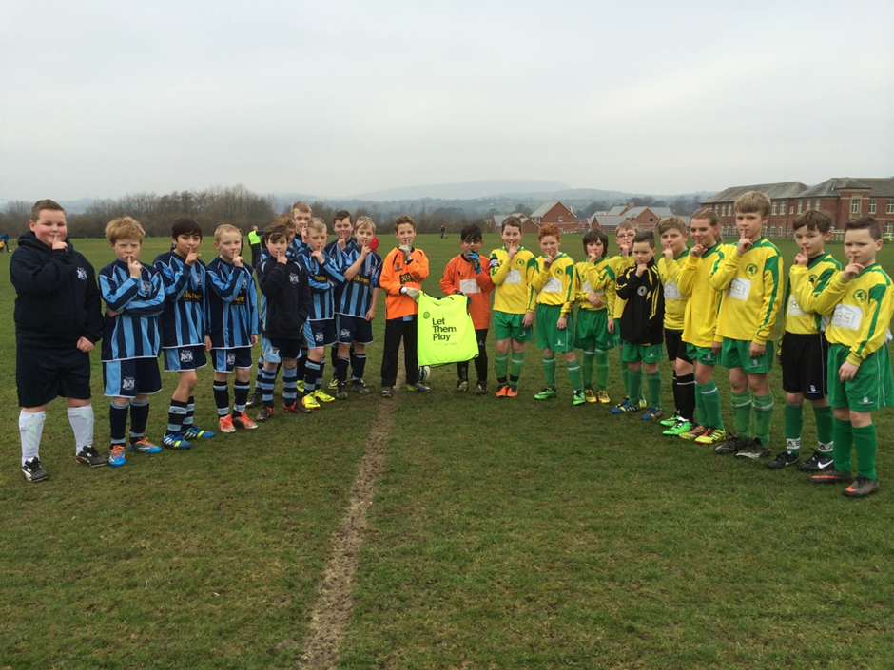

The Surveys
The surveys were created electronically in order to facilitate ease of collation of statistics and opinions. These survey forms were posted on the Silent Weekend update page on the county FA website and enquiries were signposted to the appropriate link. As with any survey we understood that we would probably receive surveys from those implacably opposed to the initiative and those very much in favour of what it sought to achieve. The more ambivalent were less likely to complete a form. That said the overall response number in excess of thirteen hundred exceeded our expectations and gave us therefore a rich source of both quantitative and qualitative data on which to build our recommendations. The surveys were open from 7th March (the day before the Silent Weekend) for two weeks given we were aware that some leagues and clubs had chosen to defer it for local reasons.
Coaches Survey (372 responses)
Q1. Did you agree with the concept of the Silent Weekend?

Q2. Did you manage to stay quiet during the game?

Q3. Rate your enjoyment compared with a normal game

Q4. Will The Silent Weekend Change The Way You Coach In Future?

Q5. Do you think your players enjoyed Silent Weekend?

Q6. Would you support the introduction of coaching areas?

Parents Survey (611 responses)
Q1. Did you agree with the concept of Silent Weekend?

Q2. Did you manage to stay quiet on the touchline?

Q3. Rate your enjoyment compared with a normal game

Q4. Do you usually shout during games?

Q5. Do you shout negative comments?

Q6. Do you think your children enjoyed Silent Weekend?

Players’ Survey (294 responses)
Q1. Was the Silent Weekend football different?

Q2. Was the game more fun?

Q3. Do you like adults cheering during the game?

Q4. Do you like adults shouting at you?

Q5. How much does your coach normally shout during games?

Referees Survey (75 responses)

Q1. Did both teams observe the Silent Weekend?

Q2. Was your refereeing experience different?

Q3. Did you find refereeing easier?

Q4. Did you find the game more enjoyable?

Q5. Did the players seem to enjoy the game more?

The Interpretation
As with any survey it is impossible to glean absolute certainties. However the number of surveys completed gives us a much more representative picture than that for which we had initially hoped. We will therefore attempt in this section to draw conclusions from the various stakeholder sectors;
Coaches
The encouraging aspect from the coach responses was that more than two thirds accepted the concept of the Silent Weekend and thus presumably the valid reasons for its organisation. As we expected nearly two thirds found the experience less enjoyable that a standard game.
“Before the game I was all for Silent Weekend but after I realised it was a step too far. The parents not shouting was great but during the game I realised the kids still needed coaching.”
This view was shared widely in the feedback given at the bottom of the forms. Interestingly the coaches who felt unable to intervene when they deemed necessary were spread across all age groups (where they divulged that information) and not just in mini-soccer where one might have expected far greater perceived need for instruction. It was a credit to our coaches that most adhered totally to being silent and only one per cent totally ignored the initiative.
The whole intention of the exercise was to provoke a discussion on how we coach children in grassroots football and whether there was any guidance we might be able to offer for future consideration. More than half of the coach respondents stated that the experience of the Silent Weekend had caused them to reflect on their practise and that reflection would result in minor or wholesale changes in approach.
“A good idea to promote a different approach, it did make me think we probably over-coach from the touchline.”
The comment mirrors those received from the chairman of a local club whose coaches held a post-match meeting to discuss their thoughts. The prevailing attitude as exemplified in the wider survey results was that enjoyment was reduced. They also considered from watching the game that a number of players were seeking direction which they were unable to give. However the conversation developed before a general consensus that possibly in the past the coaches had over-instructed and hence not created sufficient independence of thought from their players.
We accept of course that the intention to stimulate consideration of coaching practice was not embraced by all respondents. We fully appreciate that some coaches are already displaying best practice at all times. Others simply reflected that enjoyment was reduced, children could not get help, and therefore the concept itself was fundamentally flawed.
“All the players felt they had no direction during the game. As a coach I felt like I wasn’t helping my players at all.”
Indeed at least one respondent draw a clear correlation from their inability to give verbal instruction with the outcome of the match.
“Our side lost 2-1. With coaching they would have won.”
Those who did consider the Silent Weekend to have brought some benefits gave us some very interesting comments via their surveys. A significant number made reference to their pride and satisfaction in hearing their players communicate without having their enjoyment in any way compromised
“As a coach and Dad I fully support this initiative. The lads loved it and actually communicated a lot more than usual.”
“An excellent idea. It made the players more responsible for themselves. They enjoyed helping each other out.”
It was also very interesting to see how some coaches used their initiatives to try and work creatively within the parameters of the Silent Weekend. The coaches of an Under Eight team who had clearly worked on a form of sign language during the previous training session brought some genuine humour to proceedings at one venue! Another coach made an imaginative pact with his counterpart.
“We broke the game into four quarters which I think is a policy which should be researched more fully.”
In terms of written feedback from respondent coaches, the largest area of consensus concerned parental touchline input. There was virtually universal support for the concept that parents should restrict themselves to cheering and offering positive encouragement. Many coaches who replied considered parents coaching from the touchline to be totally counter-productive and undermining of their own efforts to offer leadership to the players.
“I agree parents should be quiet but coaches need to coach.”
The final question on the coach survey revolved around the issues of technical or coaching areas. This practice is already encouraged by some leagues in our county with the expectation that coaches/,managers will stand in a designated (probably coned) area for the duration of the game rather than pace up and down the touchline. We believed the majority would oppose such a scheme as unnecessarily restrictive and unrealistic. The fact that five out of six supported the idea appears to carry sufficient weight to have more detailed dialogue with our member youth leagues.
Parents
The survey results clearly demonstrate that fewer parents than coaches supported the overriding concept of the Silent Weekend. Perhaps we should acknowledge at this point that the vast majority of parents who attend youth football games restrict their vocal participation to praise and encouragement and refrain from any negativity or direction. Clearly, for those people curtailing their positive encouragement would not be popular and this fact was readily accepted from the outset. Hence this particular finding is in line with our prior expectations.
“Please get rid of all the bad parents, and most teams have one, instead of classing us all the same.”
As with our coaches we were very impressed that virtually all parents stated they remained quiet for at least the majority of the silent game. We further understand that in so doing many felt the game lacked atmosphere and the commendable “buzz” of sound present at games where children are enjoying their football, and adults are vocally supportive and constructive.
My child didn’t like how quiet it was and said there was no atmosphere. I only ever say well done and positive comments to our team”
Whilst reduced enjoyment based on lack of atmosphere was predominantly reflected in both the responses and the written feedback, there were other parents who felt somewhat differently. Indeed virtually half of parents reported they felt their child’s enjoyment had not been compromised.
“You could actually hear the players talking to each other and I’d say they found it easier to hear each other.”
“Good atmosphere. Hopefully taught some of the parents that they do not need to get as angry and involved.”
Some parents recognised the need to refrain from offering direction to a player as they identified this as purely a coach’s responsibility. This awareness may have resulted from personal experience or been articulated to them via their children or indeed the coaches themselves.
“Often instructions from parents and coaches can be conflicting and parents should learn to encourage kids and leave coaching to managers”
One of the more interesting questions answered by parents concerned the shouting of negative comments. Only four per cent of respondents admitted to ever shouting anything negative at children. This would appear to contradict the common perception and anecdotal evidence. This may be attributable to some confusion over the exact definition of the word ”negative.” It might conversely be a more accurate representation of current parental behaviour at football which would not be out of keeping with our own poor practice statistics which suggest cases involving parents and carers are decreasing annually as a percentage of the overall number. One flaw in hindsight in the players’ survey was that we did not ask if parents shouted negatively. The comparison between the adult view, and that of the children may have been interesting to quantify.
Players
The views of the players are arguably the most important for us to solicit if we are to move the grassroots youth game towards a consistently enjoyable learning experience for our children. The survey was available for children and young people aged between seven and eighteen. We were, of course, trusting in the honesty of respondents to truly fall within those age bands. Whilst it is fair to say some of the comments logged appeared a little dubious in that regard, overall we were satisfied that the vast majority of respondents were indeed minors. Listening to the views of children playing football is extremely high on the agenda of this Association and we have an urgent need within the grassroots youth game to give the participants a far more resonant voice in shaping what is, after all, their game.
The first question clearly established that there was a discernible difference in the match day experience for the vast majority of those playing during that weekend. However, compared with the adults previously analysed, opinions on the levels of enjoyment were much less definitive. Whereas coaches and parents predominantly disliked the lack of atmosphere and inability to direct, the players had mixed feelings with a split between those who were similarly frustrated, and those who reported either no change in their enjoyment, or an enhanced experience.
“I don’t like adults shouting at me when I do something wrong” … compared with…..
“I did not like Silent Weekend because there was no atmosphere and I like getting encouraged.”
Perhaps the most overwhelming conclusion to be taken from the children’s surveys and backed by the qualitative commentary was the distinction made by the children themselves between positive and negative noise levels. Ninety five per cent of children who responded were in favour of parents and carers cheering. Virtually the same number however was opposed to adults shouting at them. That places a huge challenge on us as adults to truly embrace the feelings of the players and make sure that we act accordingly to make the environment more enjoyable.
I don’t like parents shouting at me. I don’t mind the coaches shouting instructions. It’s confusing if parents and coaches both shout.”
The survey findings indicate that nearly nine in ten players have a coach who they identify shouts regularly or occasionally. They have mixed opinions on coach input when we analyse the commentary they provided. Some are clearly more reliant on direction than others and hence struggled more in its absence.
Our coaches like to give instructions but never shout at us. I also like to hear Mum and Dad cheering us on.”
“I think this idea is outrageous! Today it has cost us the game!”
Other children, who we presume occupy the thirty per cent who reported an increase in enjoyment when it was silent, were clearly less reliant on the coaches both to play, and to have fun. Some respondents identified that their scope to communicate with each other, and to have the freedom to think independent of adult intervention, was increased.
“I played a lot better when I was thinking for myself without the coach giving me ideas.”
Referees
Whilst the number of referee respondents was comparatively small, it is vital to canvas their opinions on their experience of Silent Weekend and how it might have differed from any other youth game. Last year in Lancashire, in seventy two per cent of Poor Practice cases, the person at who this practice was aimed was the match referee. Of that number the majority were aged fourteen to seventeen. In other words a significant number of young people, technically minors, were verbally abused and threatened by adults. Clearly this is upsetting and intimidating for both the young referee and their parents/carers in attendance. Whilst we have seen increases in recruitment of referees, attributable to the sterling work of our Referees Department and local leagues, certainly in areas of the county we still have mini-soccer games routinely refereed by coaches or parents even though this often results in unnecessary controversy. The haemorrhage of referees from the game is not sustainable and can only be stemmed by a cultural change in how we view referees. We can all start by noticing the child in the middle rather than the black shirt.
Of those referees who responded over ninety per cent felt it was a noticeably different experience with over three quarters concluding that it made their job easier.
“Once you made a decision it felt more final and less open to discussion. I felt a lot more respected”
Interestingly a smaller percentage of referees actually claimed to have enjoyed the game more. There is little evidence other than the commentary but this would seem to be explained by older and more experienced referees missing some of the atmosphere and banter associated with a standard game whereas the younger and less confident officials possibly felt more relaxed in the more sterile environment.
“I prefer a bit of atmosphere from the sidelines.”
“Totally pointless exercise, cannot police. In the event of abuse deal with it as required.”
The comment above is interesting in that it fails to take into account that young referees often lack the confidence, maturity, and communication skills to deal with intimidating conduct from adults. It also completely ignores the very fundamental concept that there should be no abuse of referees if the Respect agenda is to mean anything, and future recruitment to be sustained. Referees did take the time to report on what they felt to be the experiences of the other participants.
“It was amazing to hear the players talking, organising, and supporting each other”
Whilst it is fair to say that the majority of referee commentary received identified that children seemed hesitant without coach input, others did encouragingly feel that lessons were being learned.
“Refereed a game the following weekend and noticed a big difference. Seemed to have learned a lot from Silent Weekend.”
One undeniable consequence of the Silent Weekend initiative is that no referee who officiated in a game under this umbrella reported any verbal abuse or threats made directly to them. That is clearly a positive and we should take note of the fact that this group of stakeholders had a positive experience under this initiative. There is a clear need to address the culture towards football referees which is inherited from the professional and adult game and is at odds with prevailing attitudes to referees and umpires predominant in other sports. The lead on this must come from clubs and coaches given their behaviours are typically copied by the children to who they are a role model, Abuse or even continual questioning of referees is seen as normal or acceptable conduct by some children and it is inevitable that they will in time demonstrate a similar lack of respect. We have to accept that in the grassroots youth game match officials are likely to be teenagers taking their first steps in an occupation that places high demands in terms of communication, decision-making, and strength of character not normally expected of that age group. In order to hone their skills and improve as referees they need to practise in an environment where mistakes are not highlighted but where, through widespread encouragement and targeted mentoring, they are able to return the next week as better referees.
Very often this plea attracts the response that the problem of disrespect to match officials is most prominent in the professional game. That might be a fact but it is one which we, in the grassroots game cannot influence. Our duty is to ensure the team we coach or support from the touchline plays in a respectful manner and where a zero-tolerant approach to the haranguing of referees becomes a central tenet of that club’s culture and ethos. There needs to be a partnership between clubs, leagues, referee secretaries, and mentors to ensure that concerns are logged and reported constructively, and good quality mentoring provision is afforded to those identified as needing it. This is how we approach player development and there is no reason to suggest it cannot realistically become a blueprint for grassroots youth football referee development.

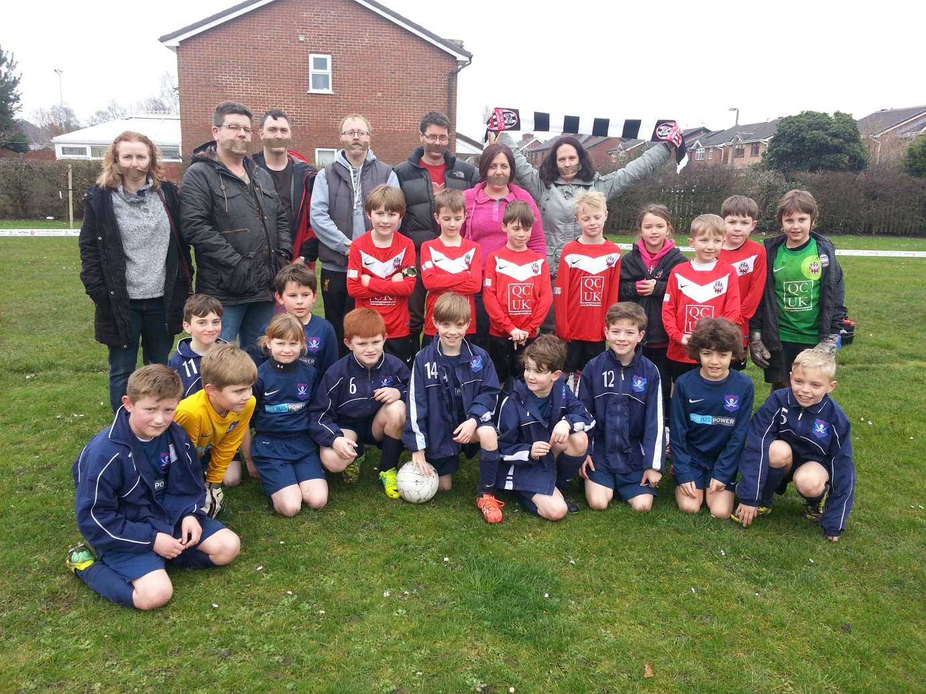

The Recommendations
As stated in the introduction to this report there was never any intention to make the Silent Weekend a regular event in the grassroots football calendar in Lancashire. The sole purpose of the initiative was to create a vigorous debate as to how the experiences of the Silent Weekend, but more importantly the reflections on those experiences might better inform us as to potential innovations in accentuating to existing improvements in adult touchline behaviour. The surveys provided a rich source of information both statistically and via the commentary and it would be absolute folly not to pay very close attention to the views of our stakeholders who felt sufficiently strongly to take the time to respond. We have also consulted other groups and researched more widely. We have listened. Any recommendations we make have to be realistic and achievable. They also need to have minimal or zero cost implications They must not bring us to into conflict with either the Laws of the Game or the Standard Code of Rules. They must also be clearly explained and have at least a degree of support if they are to be embraced by member leagues and clubs.
It is of course possible that these recommendations will not be taken on board. We understand that whilst we should be seen to offer leadership we should never be seen to dictate. All we ask is that people reading this report take the recommendations seriously and if not able to embrace the suggestions, look at other ways of achieving the same ends. Our children deserve the right to play grassroots football in a safe and enjoyable environment. They deserve the right to express themselves displaying creativity and initiative without fear of criticism. They deserve the right to be supported and encouraged by parents and carers but not be instructed or coached by them. They deserve the right to play in the best possible environment and have use of the best possible facilities. They deserve the right to develop football and wider life skills in a nurturing setting freed from the adult-orientated agendas of score-lines and league tables. Anything the fantastic people in grassroots football in Lancashire can do to move us towards those goals is to be applauded and will be fully supported by this Association.
Coaching
Lancashire is blessed with a huge number of committed grassroots youth football coaches. Without exception they give of their time freely and willingly with no question of recompense. Often they come to the rescue of a team about to disband with little appreciation of the amount of work involved in subsequently co-ordinating that team. The majority of these men and women readily embrace training and we continue to recruit healthy numbers onto Level One Coaching Courses throughout the county. Many go beyond this baseline qualification and eagerly engage with continuous professional development, and attend enhanced courses. The FA Youth Module Awards are critical to youth football development as they concentrate specifically on the needs of children, and the creation of an environment best suited to those needs. It is not for the unqualified author of this report to scrutinise how coaching courses are delivered by the county FA and national governing body. However it is clear from the reflections of a good number of coaches in addition to comments received that there is still a need for further education into just how children learn. Several skilled coaches concluded that they have been over-coaching children and in the process have stifled creativity, independent thinking, and created a situation where players have become totally reliant on the coach moving them around the field of play. Further discussions will take place with coach educators to see how these important points can be more powerfully embedded on a consistent basis.
The predominant figure in poor practice in Lancashire remains the coach or manager. Since the advent of Respect barriers parents have been physically but also psychologically removed from the touchline with huge consequential improvements in their conduct. The time has come to similarly constrain our coaches by making coaching areas mandatory. These can be artificially marked out but both areas should be in close proximity. This will theoretically prevent coaches running up and down the touchline and becoming too emotionally absorbed in the game.
- Coaches to stand in coaching areas during all grassroots youth football games. Referees to monitor adherence and report any breaches to the league.
There is clearly a propensity in some areas for coaches to be too vocal in terms of both volume, and the number of times they are verbally communicating. All coaches are different and some talk more than others whilst some observe and make notes more than others. We accept there is no rigid method of communicating effectively with children playing football. What is clear from the surveys is that players do not like being shouted at and do not benefit from excessive instruction where long-term development is concerned. There will be understandable concern from some coaches that reduced communication might result in reduced performance levels. In noting this concern, there is a trade-off in the Leagues section of these recommendations.
- Coaches to refrain from shouting negatively at players and should only communicate when absolutely necessary.
We are still witnessing coaches trying to develop an elite squad at a grassroots community club which is in breach of the whole concept of that club’s existence. Too many players are being labelled too early. Playing with friends is a hugely powerful motivator for children yet adults prevent that happening on the grounds of selection. To the child watching from the touchline, being a substitute is not playing with his or her friends. As the children get older then a first choice team may evolve with some players becoming a little more peripheral. This of course prepares older age groups for the transition into open-age football but still needs to be managed sensitively if we are to retain them as players. However there can be no excuse at junior school ages (Under Eleven and below) for coaches not facilitating an equal game time policy for all squad members.
- Coaches of Under Eleven teams and younger should rotate their squads to allow roughly equal game time during a season. This to be an expectation of all clubs, leagues, and the county FA.

Parents
Parental behaviour in grassroots football is largely excellent and improving annually. The vast majority of parents and carers are hugely supportive of their children and clubs offering only positive praise and making sure the touchline atmosphere is exciting but respectful and always conducive to the best interests of the children playing. The survey’s findings that parents do not shout negatively at children were not mirrored totally by the young people’s responses. Perhaps the crux of that disparity lies in the true definition of the word “negative?” What is clearer is that there was widespread concern from coaches regarding parents shouting football-based instructions to their children during the game. Often this conflicts with the guidance from the designated coach and inevitably can be confusing or irritating to the players. Most parents do this innocently, and in a genuine attempt to help their offspring. A small number may feel their opinion is more valid of that of the coach and this can cause internal disquiet between those adults.
- Parents to refrain from offering any coaching advice or instruction to their children. Vocal output to be limited positive encouragement of all players irrespective of team. Clubs to be responsible for policing adherence.
Clubs reserve the right to rescind membership to any parent/carer who undermines coaches and managers on a regular basis. This mirrors the expectation of academies in professional clubs where parental coaching is strictly forbidden.
Young Players
In some ways the conclusions of this report with regards to the players are the most important. After all it is their game and the adults are merely custodians and facilitators. Historically we took the model of adult football and built the youth game on that familiar foundation. Throughout the evolution of youth football we have recognised the structural implausibility of that model and great work has been carried out in making the game much more child-friendly. The whole purpose of the Silent Weekend was to look at those areas of the youth game that have not been previously addressed with the same level of scrutiny. In the process of organising the event, collating the feedback, and consulting more widely, it is clear that young people do not have anything like a powerful enough voice in decisions made about their game. Adults dictate the agenda. Children do as they are directed. The Silent Weekend gave us an opportunity to approach young people with a different mind-set. We have the opportunity to give them more freedom on the field during the games. However we also have a massive opportunity to drastically enhance the involvement of young people off the field.
- Lancashire FA to recruit a Youth Council to be in place from September 2014 with membership open to applicants from all stakeholder groups between the ages of fourteen and twenty-five.
This group will be self-governing, self-financing, and has been promised a clear line of communication to the county FA Council and Board of Directors.
It is right that the county FA should lead the way in giving a medium for young people to share their views on the game. However if that voice is to be sufficiently loud, the representation of young people in our clubs and leagues needs to be accepted and accelerated. Adults continue to exclusively shape how clubs are run and how leagues operate. Whilst we have superb volunteers at the helm of both, it does not negate the intrinsic right of young people to be adequately represented.
- Clubs to create a youth committee or elect a youth member onto the full club committee for the 2014-15 season. Leagues to have youth committee member by 2015-16 season.
We would also like clubs to really consider new and innovative ways of expanding the involvement of young people in clubs. Many clubs have already woken up to the potential benefits of this. Players who are encouraged to put together a short session at their own training nights, on a rota basis, often develop great confidence from this activity. Clubs can then benefit from harnessing young coaching talent to help out the youngest teams and hence increase the chances of retention of that player at an age when too many are lost to the game. There must also surely be scope for young people to be involved discussions into how the team operates on match days. In academies, we hear of players being asked to deliver team talks and debriefs. We hear of them being consulted as to improvements in formation, or who plays in which positions. This type of innovation is already common practice in some grassroots teams but we need to extend the concept and in the process truly empower many more young people to have a say in their game, making them more confident, independent and capable of solving their own problems. A youth game shaped by young people will be far more relevant to their needs and theoretically will have real consequences in terms of improved retention but more importantly enhanced enjoyment.
Referees
It is now over six years since the Respect programme was introduced by the FA in response to a huge survey of stakeholders across the game that concluded that touchline behaviour, and specifically abuse to referees, was the major concern of respondents. The measures introduced as part of this programme such as the Respect barriers, and the greater use of the captain as an intermediary, have been certainly successful. However, our own statistics compiled over the past four season consistently point to the fact that in the majority of poor practice cases, it is the referee who is on the receiving end. Of those, we have identified that referees aged fourteen to eighteen are the most vulnerable group. Given they are technically minors this inevitably has safeguarding children implications. It would be disingenuous to draw a clear correlation between poor treatment of referees and the difficulties in retention during the teenage years. We know that once young people start to earn money in other ways, some become less inclined to referee. Others simply conclude after a period of time that refereeing is not for them. However, there are still young people who walk away from refereeing as a result of a distasteful experience, intimidation, or even threats.
Whilst we have already identified that several measures are in place to educate adults to refrain from targeting referees so overtly, we also need to ensure that optimum support mechanisms are in place for young referees to develop their resilience and hence enhance the prospects of them returning strongly from any perceived setback. Despite the excellent work of the county FA Referees Department in recent years, mentoring of young referees is still sporadic in terms of geographical coverage. Mentoring should not be a postcode lottery. However that must be balanced against the reality that mentors operate on a purely voluntary basis. Recruitment of suitable people therefore remains a challenge given they will almost certainly be out of pocket. This reality should not necessarily, however, be a barrier to seeking a more consistent mentoring coverage.
- Leagues to liaise with local Referees Associations to plan and deliver a Mentoring Programme for young and inexperienced referees. Both leagues and RAs to consider using existing funds to cover travelling expenses of mentors or to reward their commitment in other ways.
Once qualified there are few opportunities for young referees to develop their experience and knowledge other than by simply refereeing games. Further tuition and training is not introduced until that referee reaches the bottom of the promotion ladder and where they may be included in county FA groups such as the Academy or Young Potentials. In the interim it is inevitable that some erstwhile promising officials will have fallen by the wayside. The only scope to offer training, guidance, and the pastoral support so valued by their parents and carers is via the local Referees Associations. Much great work has been done in recent years to make these bodies more accessible, and relevant to the needs of the youngest and most experienced young officials. However, there is still an urgent need to ensure that EVERY candidate from a basic referees’ course is contacted directly by his or her local Association and offered free membership for the first, critical season.
- Local Referees Associations to offer free membership for the first year to all newly qualified referees and ensure each is contacted directly to extol the intrinsic value of membership.
If we are advocating that young players have a much more prominent voice in their game, then surely the same should apply to young referees. The reinvigoration of the Lancashire RA as an umbrella organisation for most local associations in the county provides an excellent platform for new officials to consider that meeting attendance is valuable, and to feel more at ease in the surroundings. The local associations have long since concluded that to guarantee their own sustainability and longevity, they need to encourage new blood and change the way in which they operate, and how business is conducted. Now they need to embrace giving those young referees a clear line of communication.
- Lancashire RA to have a youth council reporting to the main committee ensuring that all young officials have a forum whereby their opinions and concerns can be articulated without fear or favour.
Clubs
The vast majority of clubs in the county are superbly organised and provide a tangible and often influential service to the young people in their community. The tireless work of their many volunteers is wonderful and should not be in any way denigrated by any recommendations in this report. The suggestions above to incorporate greater inclusion on match days, and a greater say for young people in how their clubs are run should have real benefits for the clubs that are willing to embrace this guidance.
We would urge clubs to consider just how they can make the match-day environment much friendlier and hence enjoyable. The typical sight of two sets of adults stood at opposite ends of the touchline, or directly across from each other owes everything to the parochial culture inherited from the adult game. These are people with much more in common than they have differences and yet they feel they cannot interact with each other. This has to change if we are to eliminate any hostility that sadly all too often affects the game itself. At some venues there is the potential for refreshments to be made available. This provision can have a unifying effect as can children offering sweets or an alternative post-match gift to their opponents. Low cost financially, but of huge reputational value. We would encourage all clubs to really consider how they can maximise hospitality. In doing so it becomes more of a social occasion than a football match, it makes the atmosphere far more cordial and enjoyable for the children, but may also have positive implication in terms of the number of adults who attend games and thereby develop a closer attachment to their children’s club.
- Leagues to offer a Hospitality Award to the team given highest grades by visiting teams on post-match feedback forms. This could be on a league or divisional basis.
We have identified that clubs which embrace education opportunities have figured far less prominently in subsequent poor practice cases. Much of the poor practice that exists in youth football is a direct result of adults becoming too absorbed in the game, and not being able to differentiate between what motivates adults, and what is important to children.
- All clubs to consider hosting Adults In Junior Football Workshop during 2014-5, or a different follow-up session for those clubs who have previously accessed it.
Leagues
Lancashire is blessed with proactive and superbly-run youth leagues some of whom have historically and currently been identified as being pioneering in certain areas. We wish to call on the expertise and experience of league officials to help us ensure that all games can be played in a supportive and enjoyable atmosphere on a consistent basis. We are acutely conscious that committee resources are already stretched and that many league officers are already overworked. We have therefore sought to recommend initiatives that will not significantly impact on that existing workload.
One source of constant concern in poor practice is the disproportionate number of incidents arising from games where the referee is not qualified or independent. For some there is a sad assumption that the occupant of the role is cheating given their clear club allegiance. The only way to overcome this reality is to recruit sufficient neutral referees to cover the programme of fixtures. We currently have a geographical imbalance with some areas having too many referees, and others with virtually no coverage.
- Leagues with insufficient qualified referees to work closely with local RA and Lancashire FA Referees Department to look at recruitment and retention initiatives.
Another clearly identified source of touchline friction is the role played by some club linesmen or assistant referees. Again there is often a pre-conceived opinion that the person discharging the duties is not capable of impartiality whereas in reality, errors are more often than not attributable to poor judgement or lack of appreciation of the laws of the game especially in regards to offside. This perception is not helped by those running the line who choose to use their position to organise the defensive line, or offer advice to other players during play
- Leagues to host a course for club assistants organised in conjunction with the local RA and county FA Referees Department to cover basic duties of the job and offer consistent advice on the interpretation of offside. No coaching to be given from the line. Each team to be encouraged to recruit a designated person to fulfil these duties as regularly as possible.
One of the major points to consider from the Silent Weekend and the surveys received is the volume and regularity with which coaches communicate with their players. We wish to establish a norm whereby coaches and managers only offer directionwhen absolutely critical but otherwise take notes and use breaks in play to reorganise or offer support and encouragement. This model is common practice in academies. Whilst we accept the standard of player in grassroots leagues may be slightly lower, the players are still children who become confused by multiple directions, and who need to have the opportunity to develop an independence of thought, and a sense of responsibility. Earlier in these recommendations we have asked coaches to rein back their vocal input. However, the concerns from coaches in their surveys about the need for direction cannot simply be ignored. As a trade-off therefore we are asking;
- Leagues to split all games into four periods to allow coaches time outside of the game to help their young players and make any necessary amendments. This to be achieved through liaison with referees, the extra breaks to be classed as refreshment breaks and limited to two to three minutes.
Leagues are aware that in terms of disciplinary sanctions, most of this function has now been devolved to the county FA Disciplinary Department. Therefore any attempts to look at repeat offenders need to be placed in that context. Leagues do however have the authority, via an EGM to put a motion forward expelling any club deemed to be bringing that league into disrepute. The negative consequence of such a decision is that potentially, innocent young people will be denied the opportunity to play by the poor behaviour of adults. We would therefore like leagues to consider creative ways, within the code of rules, to demand an educational resolution of clubs who cross the line of acceptable behaviour.
- Leagues to make Adults In Junior Football Workshop mandatory where the league feels a team or club’s behaviour is unacceptable.
County FA
It is vital that the county FA leads by example if the Silent Weekend is to have any meaningful legacy for young people playing football in Lancashire. We have already in these recommendations committed to setting up a county FA Youth Council to empower our young stakeholders from their various sectors, and giving them a genuine voice in how football operates in the county but also in assisting us in the drive to increase participation at those age groups where we have historically seen a drop-off in participation. We are also conscious that some youth leagues sometimes feel frustrated that their challenges, opinions, and recommendations are not sufficiently recognised by the county FA. These concerns are spread across various areas such as finance, discipline, recruitment of referees, facilities, and support from the county FA. There is an opinion that the county FA has tended to instruct rather than consult. Whilst that may or may not have validity, it is critical that to bring about the improvements we all wish to see, that we proceed in a genuine state of collaboration and transparency.
At present there is a youth football representative sitting on the county FA council. Beyond that there is no formal structure for youth football to have a voice. We do have a Welfare Officer Working Group consisting of club and league welfare officers but that group’s remit tends to be concerned mostly with safeguarding related issues. There is clearly the scope to extend not only the membership of this group, but also its terms of reference.
- Lancashire FA to create a Youth League Forum from its existing WO Working Group. Forum to be representative of clubs, leagues, and other stakeholders, be independently chaired, and to have scope to make recommendation to county FA

The Conclusions
From the outset of the Silent Weekend planning period, it was never the intention for this event to be replicated on a regular basis. The sole purpose of the initiative was to draw attention to the issue of poor practice in youth football, solicit the views of as many participants as possible, and then make recommendations for future discussion. It must be reiterated that this is purely a consultation document. There has been only a limited discussion thus far on some of the recommendations whilst others are totally new initiatives. What is essential is that all stakeholders have the time to digest the contents of the report and make their feelings known. Hopefully this process can take place in sufficient time to allow any new proposals to be put to clubs in time to be implemented for the 2014-5 season. It is quite plausible that some of the recommendations made may not be implemented but replaced by other plans to arrive at the same outcome.
In conclusion we must once again place on record our sincere gratitude for the great work carried out by all of our volunteers in grassroots youth football. Your selfless commitment to your clubs and leagues ensures that children have the opportunity to enjoy the game on a weekly basis in an enjoyable, well-organised, and structured format. We hope that any changes made in the light of the Silent Weekend enhance that provision, and if anything make your jobs easier. You are all very special people and worthy of the highest acclaim.
We hope that the Silent Weekend has not been a waste of people’s time but instead provides a firm foundation on which to build a better, more enjoyable version of the game our children play. Our children, and future young players, deserve nothing less.

The Reference List
Brackenridge, C, Pitchford, A, Russell, K, Nutt, G. (2007) Child Welfare In Football Abingdon: Routledge
Goldberg, A. (2014). Competitive Advantage. Available: www.competitive.edge.com/yellinganger-sports. Last accessed 24th March, 2014
Humphrey, J Yow, D. (2002). Adult Guide To Children's Sports. New York: Nova Science.
Jones, R. (2009). Coaching As Caring: Accessing Hidden Knowledge. Physical Education And Sports Pedagogy. 14 (1), 377-390.
Kidman, L, McKenzie, A, Mckenzie, B. (1999). The Nature And Target Of Parents’ Comments During Youth Sports Competitions. Journal Of Sport Behaviour. 22 (1), 54-68
Lee, M (2002). Coaching Children In Sport. Abingdon: Taylor and Francis.
Mageau, G, Vallerand, R. (2003). The Coach-Athlete Relationship, A Motivational Model. Journal Of Sports Science 21 (1), 883-904.
Telfer, H, Brackenridge, C (2011). Coaching Children In Sport. New York: Routledge.

